**QUERY:**

1) Give name of depositors having amount greater than 4000.

**INPUT :-**

Select cname from deposit where amount <4000;

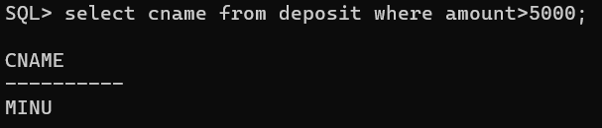

**QUERY:**

2) List the employees having salary less than 22000.

**INPUT :-**

Select Emp_name from work where salary >22000;

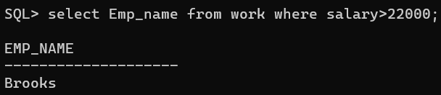

**QUERY:**

3) List the sailors having age more than 25.

**INPUT :-**

Select Sname from sailors where age>25;

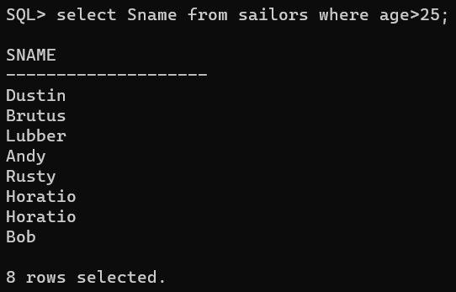

**QUERY:**

4) List the boats travelling on 10-oct-98

**INPUT :-**

Select Bid from reserves where day=’10-oct-98’;

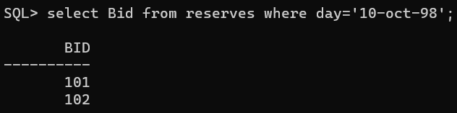

**QUERY:**

5) List the details of boat “Interlake”.

**INPUT :-**

Select *from boats where bname=’Interlake’;

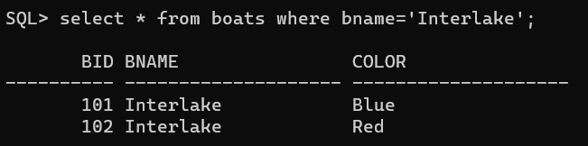

**QUERY:**

6) List the details of the red colored boat.

**INPUT :-**

Select *from boats where color=’red’;

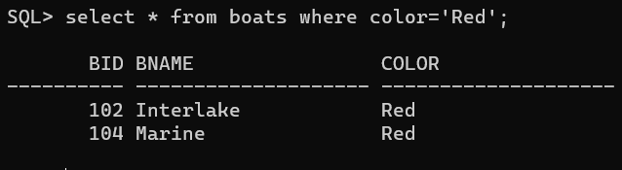

**QUERY:**

7) List the details of clients whose city is Mumbai

**INPUT :-**

Select *from Client where City=’Mumbai’;

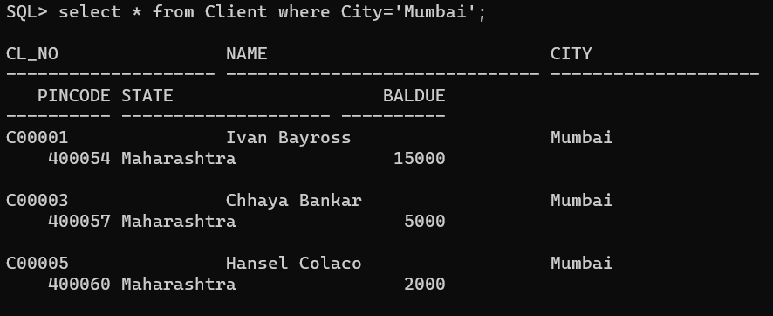

**QUERY:**

8) List Client Name, due balance and city of the clients having balance greater than 1500.

**INPUT :-**

Select name, baldue, city from Client where baldue>1500;

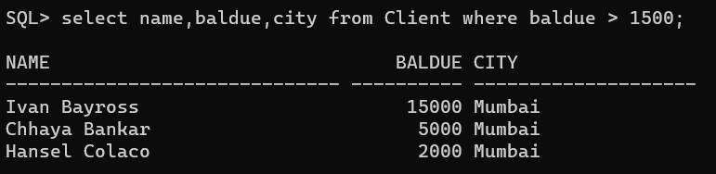

**QUERY:**

9) Describe the details of products having selling price less than 500.

**INPUT :-**

Select *from Product where sell_price<500;

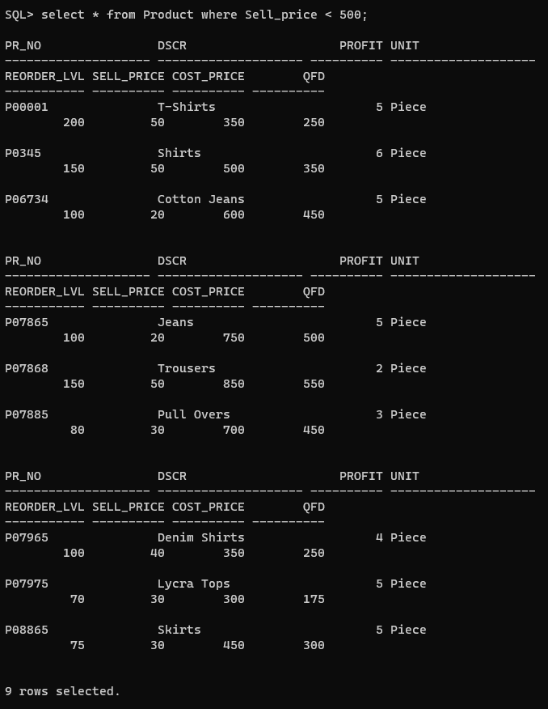

**QUERY:**

10) List the products for which quantity ordered is less than 120 and cost price is greater than 250.

**INPUT :-**

Select *from Product where cost_Price>250;

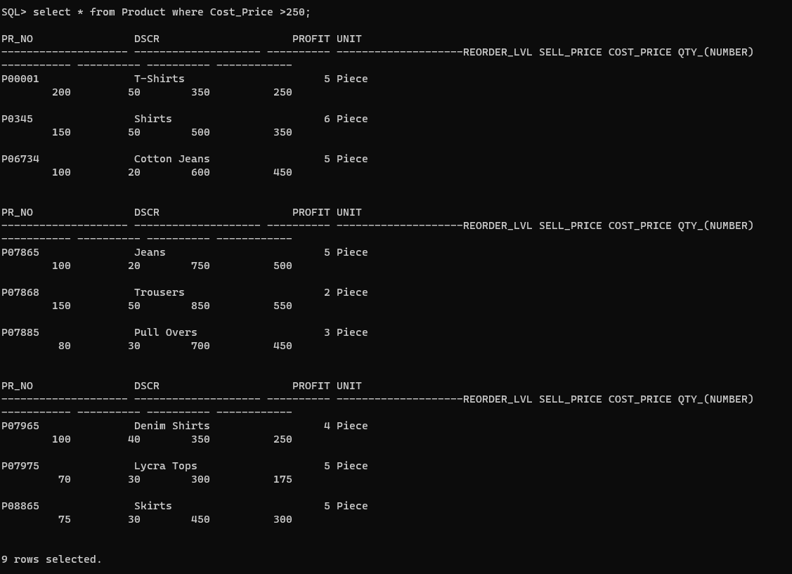

**QUERY:**

11) Display account details having amount greater 2200.

**INPUT :-**

Select *from Deposit where Amount>2200;

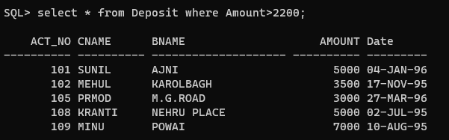

**QUERY:**

12) Display all the customers staying in Nagpur

**INPUT :-**

Select *from Customers where city>’Nagpur’;

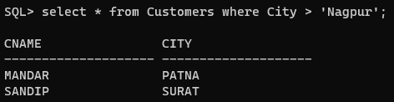

**QUERY:**

13) Display the names of sailors having rating greater than 7

**INPUT :-**

Select Sname from Sailors where Rating >7;

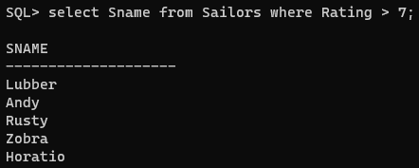

**QUERY:**

14) Display the orders made in the month of June

**INPUT :-**

Select *from Salesorder_details where qty_disp>3;

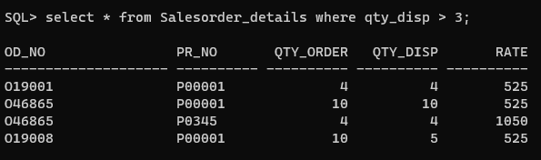

**QUERY:**

15) List all the accounts created in the month of March

**INPUT :-**

Select act_no from Deposit where Date_D BETWEEN ’27-MAR-96’ AND ‘31-MAR-96’;

